NAME: SHAHEER KHAN
REG NO: 71870
NAME: MUHAMMAD HAZIQ
REG NO: 71955
COURSE: DATA STRUCTURE
PROGRAM: BSSE
TIMING: 8:30-11:20
DAY: FRIDAY
CCA

TITLE: ATM MANAGEMENT SYSTEM:
1)INTRODUCTION:
The system is a java application designed to simulate the basic ATM process like balance inquiry, check withdrawal, cash deposit and small statement generation. The ATM Management System shows the functional use of OOPs concepts along with multiple data structures for educational and learning purposes.
2)GOALS:
- To show real world ATM functions.
- To use OOP principles such as abstraction, encapsulation and interfaces.
- To show the utilization of many data structure in one application.
- To give a clear insight of transaction handling.
3) SYSTEM OVERVIEW:
The system verify a user using an account number and PIN. Once verification is complete, the user can perform various functions with the help of a menu-driven interface. All functions are handled with a well-defined interface and its execution.
4)TECHNOLOGIES APPLIED:
- Programming language: JAVA.
- Java concepts: OOP, interfaces, Collections Framework.
- JAVAFX.
- DATA STRUCTURE USED: Array, ArrayList, HashMap, Stack.
- Input Handling: Scanner class.
5)CLASS AND INTERFACE DESCRIPTION:
ATM class:
- It contains account-related information such as balance, and withdrawal amount.
- Methods like getter and setter are being used here to use and change these values and making sure encapsulation.
ATM OPERATION INTERFACE:
Stating the core ATM functions:
1)View balance.
2)Withdraw amount.
3)Deposit amount.
4)View mini statement.
This interface give abstraction and make sure consistency in execution.
ATM Operation Impl Class:
Execute all the methods state in the interface. This class consist the core business logic and manages all data structures utilized in the system.
Javafx: Handles user interface.
DATA STRUCTURE USED AND THEIR PURPOSE:
HashMap:
- Contain transaction amounts with their type( deposit or withdrawal).
- Use for making mini statements.
ArrayList:
- Contains all deposited amounts.
- Enable dynamic resizing and easy transversal.
Stack:
- Keep track of action history(LIFO order).
- Useful for tracking recent functions.
Array:
- Contain the last 5 transactions.
- Give the user fixed sized transaction history.
ALGORITHMS EXECUTED:
Verification Algorithm:
- Take account number.
- Confirm account number.
- Take the PIN.
- Grant access if credentials match.
- Deposit Algorithm:
- Take deposit amount.
- Update balance.
- Contain transaction in HashMap, ArrayList, Stack, and Array.
Withdrawal Algorithm:
- Take withdrawal amount.
- Verify multiple of 500
- Confirm sufficient balance
- Reduce amount and record transaction.
Mini statement Algorithm:
- Show all transactions from HashMap.
- Show last 5 transactions from Array.
- Show deposit history from ArrayList.
- Show action history from Stack.
VERIFICATION AND ERROR HANDLING:
- Wrong account number handling.
- Wrong PIN retry mechanism.
- Insufficient balance confirm.
- Wrong withdrawal amount confirmation.
ADVANTAGES:
- User friendly GUI.
- Simple and easy to understand design.
- Show many data structures.
- Good example of OOP principles.
- Suitable for academic and learning purposes.
LIMITATIONS:
- Single user support.
- No database connection.
- Hardcoded account number and PIN.
- Console based interface only.
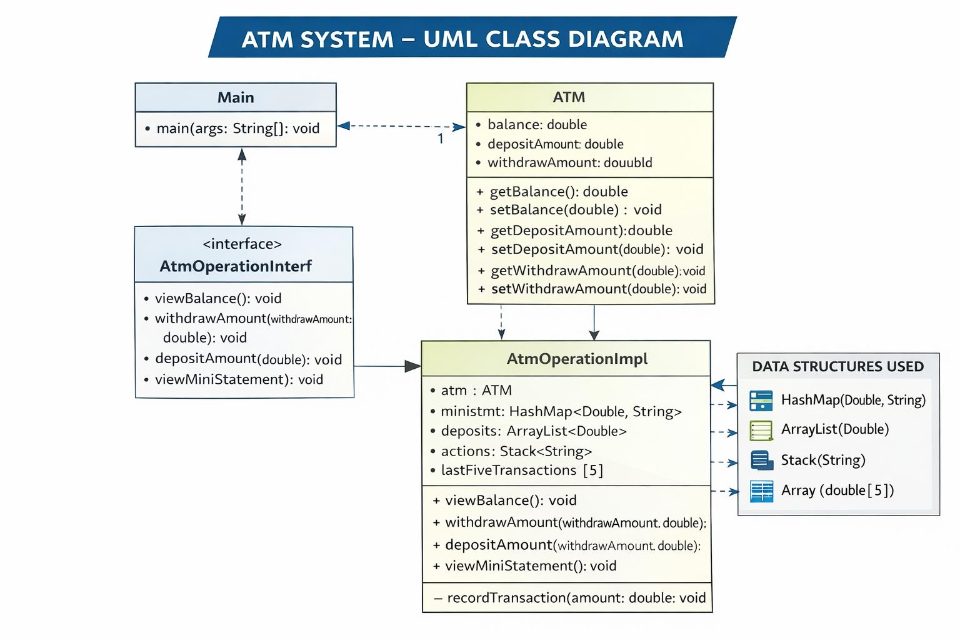
UML DIAGRAM:
DATA STRUCTURE DIAGRAM:
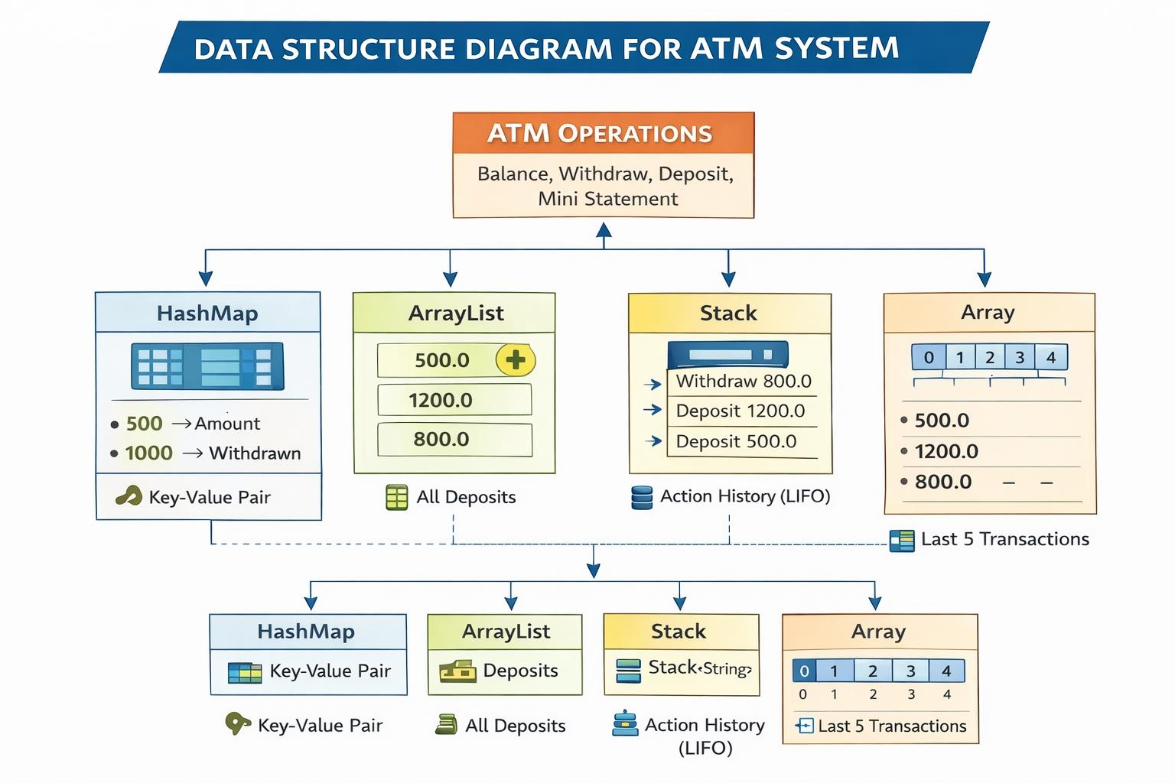
DELIVERABLES:
1)Source Code.
2. Graphical User Interface (GUI)
- JavaFX-based user interface
- Interactive buttons for ATM operations.
- Input field for transaction amount.
- Real-time output display area.
- User-friendly and intuitive layout.
3. Data Structure Implementation
4. Algorithms Implemented
5. UML Class Diagram
6. Data Structure Diagram:
- Array structure (last 5 transactions)
- Stack (action history)
- ArrayList (deposit records)
- HashMap (small statement entries)
7. System Report Descriptive project documentation
8. Testing and Confirmation.
9. Academic Readiness good for final project
CONCLUSION:
This system successfully shows how core ATM functionalities can be executed using java, OOPS concepts and multiple data structure. It serve one of the best example for the understanding java and adding javafx makes it more appealing to the users.
CODE OF JAVA:
import java.util.*;
public class Main {
static class ATM {
private double balance;
private double depositAmount;
private double withdrawAmount;
public double getBalance() {
return balance;
}
public void setBalance(double balance) {
this.balance = balance;
}
public double getDepositAmount() {
return depositAmount;
}
public void setDepositAmount(double depositAmount) {
this.depositAmount = depositAmount;
}
public double getWithdrawAmount() {
return withdrawAmount;
}
public void setWithdrawAmount(double withdrawAmount) {
this.withdrawAmount = withdrawAmount;
}
}
interface AtmOperationInterf {
void viewBalance();
void withdrawAmount(double withdrawAmount);
void depositAmount(double depositAmount);
void viewMiniStatement();
}
static class AtmOperationImpl implements AtmOperationInterf {
ATM atm = new ATM();
Map<Double, String> ministmt = new HashMap<>();
ArrayList<Double> deposits = new ArrayList<>();
Stack<String> actions = new Stack<>();
double[] lastFiveTransactions = new double[5];
int transactionIndex = 0;
@Override
public void viewBalance() {
System.out.println("Available Balance is: " + atm.getBalance());
}
@Override
public void withdrawAmount(double withdrawAmount) {
if (withdrawAmount % 500 == 0) {
if (withdrawAmount <= atm.getBalance()) {
ministmt.put(withdrawAmount, " Amount Withdrawn");
System.out.println("Collect the Cash: " + withdrawAmount);
atm.setBalance(atm.getBalance() - withdrawAmount);
recordTransaction(withdrawAmount);
actions.push("Withdraw " + withdrawAmount);
viewBalance();
} else {
System.out.println("Insufficient Balance !!");
}
} else {
System.out.println("Please enter the amount in multiple of 500");
}
}
@Override
public void depositAmount(double depositAmount) {
ministmt.put(depositAmount, " Amount Deposited");
deposits.add(depositAmount);
System.out.println(depositAmount + " Deposited Successfully !!");
atm.setBalance(atm.getBalance() + depositAmount);
recordTransaction(depositAmount);
actions.push("Deposit " + depositAmount);
viewBalance();
}
@Override
public void viewMiniStatement() {
System.out.println("\n---Mini Statement---");
for (Map.Entry<Double, String> m : ministmt.entrySet()) {
System.out.println(m.getKey() + " " + m.getValue());
}

System.out.println("\nLast 5 Transactions:");
for (double t : lastFiveTransactions) {
if (t != 0)
System.out.println(t);
}
System.out.println("\nAll Deposits: " + deposits);
System.out.println("\nAction History:");
for (int i = actions.size() - 1; i >= 0; i--) {
System.out.println(actions.get(i));
}
}
private void recordTransaction(double amount) {
lastFiveTransactions[transactionIndex % 5] = amount;
transactionIndex++;
}
}
public static void main(String[] args) {
AtmOperationInterf op = new AtmOperationImpl();
int accnumber = 12345;
int atmpin = 123;

Scanner in = new Scanner(System.in);
System.out.println("Welcome to ATM Machine !!!");
System.out.print("Enter Account Number: ");
int accNumber = in.nextInt();
if (accNumber != accnumber) {
System.out.println("Sorry! No account found with " + accNumber);
System.exit(0);
}
boolean cond1 = false;
do {
System.out.print("Enter Pin: ");
int pin = in.nextInt();
if (accnumber == accNumber && atmpin == pin) {
while (true) {
System.out.println("\n1. View Balance");
System.out.println("2. Withdraw");
System.out.println("3. Deposit");
System.out.println("4. Mini Statement");
System.out.println("5. Exit");
System.out.print("Enter Choice: ");
int ch = in.nextInt();
if (ch == 1) op.viewBalance();
else if (ch == 2) {
System.out.print("Enter amount: ");
op.withdrawAmount(in.nextDouble());
} else if (ch == 3) {
System.out.print("Enter amount: ");
op.depositAmount(in.nextDouble());
} else if (ch == 4) op.viewMiniStatement();
else if (ch == 5) {
System.out.println("Thank you for using ATM!");
System.exit(0);
} else {
System.out.println("Invalid choice");
}
}
} else {
System.out.println("Incorrect PIN. Try again.");
cond1 = true;
}
} while (cond1);
in.close();
}}
OUTPUT:
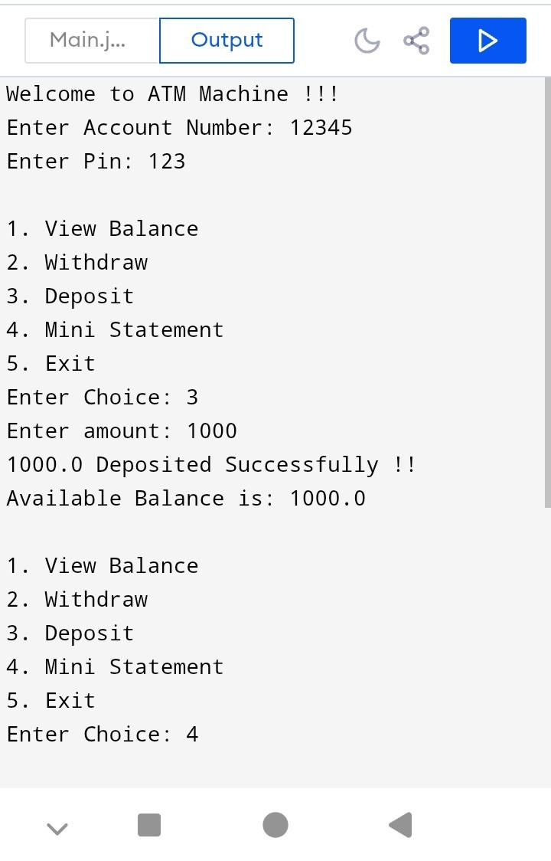
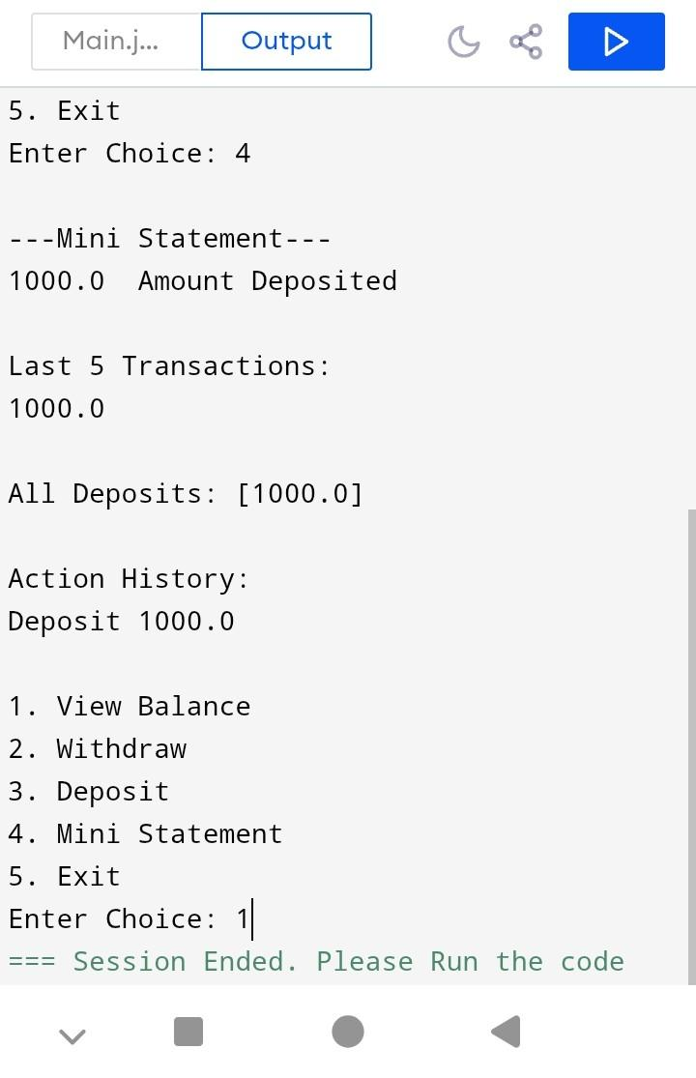
JAVAFX CODE:
import javafx.application.Application;
import javafx.geometry.Insets;
import javafx.scene.Scene;
import javafx.scene.control.*;
import javafx.scene.layout.VBox;
import javafx.stage.Stage;
import java.util.*;

public class Main extends Application {

static class ATM {
private double balance;
public double getBalance() { return balance; }
public void setBalance(double balance) { this.balance = balance; }
}

interface AtmOperationInterf {
void viewBalance();
void withdrawAmount(double amount);
void depositAmount(double amount);
String viewMiniStatement();
}

static class AtmOperationImpl implements AtmOperationInterf {
ATM atm = new ATM();
Map<Double, String> ministmt = new HashMap<>();
ArrayList<Double> deposits = new ArrayList<>();
Stack<String> actions = new Stack<>();
double[] lastFive = new double[5];
int index = 0;

public void viewBalance() {}

public void withdrawAmount(double amount) {
if (amount % 500 == 0 && amount <= atm.getBalance()) {
atm.setBalance(atm.getBalance() - amount);
ministmt.put(amount, "Withdrawn");
actions.push("Withdraw " + amount);
record(amount);
}
}

public void depositAmount(double amount) {
atm.setBalance(atm.getBalance() + amount);
deposits.add(amount);
ministmt.put(amount, "Deposited");
actions.push("Deposit " + amount);
record(amount);
}

public String viewMiniStatement() {
StringBuilder sb = new StringBuilder();
sb.append("Mini Statement:\n");
for (Map.Entry<Double,String> e : ministmt.entrySet())
sb.append(e.getKey()).append(" ").append(e.getValue()).append("\n");

sb.append("\nLast 5 Transactions:\n");
for (double d : lastFive)
if (d != 0) sb.append(d).append("\n");

sb.append("\nDeposits:\n").append(deposits).append("\n");
sb.append("\nActions:\n");
for (int i = actions.size() - 1; i >= 0; i--)
sb.append(actions.get(i)).append("\n");

return sb.toString();
}

private void record(double amount) {
lastFive[index % 5] = amount;
index++;
}
}

AtmOperationImpl op = new AtmOperationImpl();

@Override
public void start(Stage stage) {
TextField amount = new TextField();
Label output = new Label();

Button balanceBtn = new Button("View Balance");
Button withdrawBtn = new Button("Withdraw");
Button depositBtn = new Button("Deposit");
Button miniBtn = new Button("Mini Statement");

balanceBtn.setOnAction(e ->
output.setText("Balance: " + op.atm.getBalance()));

withdrawBtn.setOnAction(e -> {
double a = Double.parseDouble(amount.getText());
op.withdrawAmount(a);
output.setText("Balance: " + op.atm.getBalance());
});

depositBtn.setOnAction(e -> {
double a = Double.parseDouble(amount.getText());
op.depositAmount(a);
output.setText("Balance: " + op.atm.getBalance());
});

miniBtn.setOnAction(e ->
output.setText(op.viewMiniStatement()));

VBox root = new VBox(10, amount, balanceBtn, withdrawBtn, depositBtn, miniBtn, output);
root.setPadding(new Insets(20));

stage.setScene(new Scene(root, 400, 500));
stage.setTitle("ATM System");
stage.show();
}

public static void main(String[] args) {
launch(args);
}
}

